**Example of ANOVA**

(Table 3.2 of recommended text)

Fluoresence from solutions stored under different conditions.

|  |  |  |
| --- | --- | --- |
| Conditions | Replicate Measurements | Mean |
| A: Freshly Prepared  B: Stored for 1 hour in the dark  C: Stored for 1 hour in subdued light  D: Stored for 1 hour in Bright light | (102,100,101)  (101,101,104)  (97,95,99)  (90,92,94) | 101  102  97  92 |

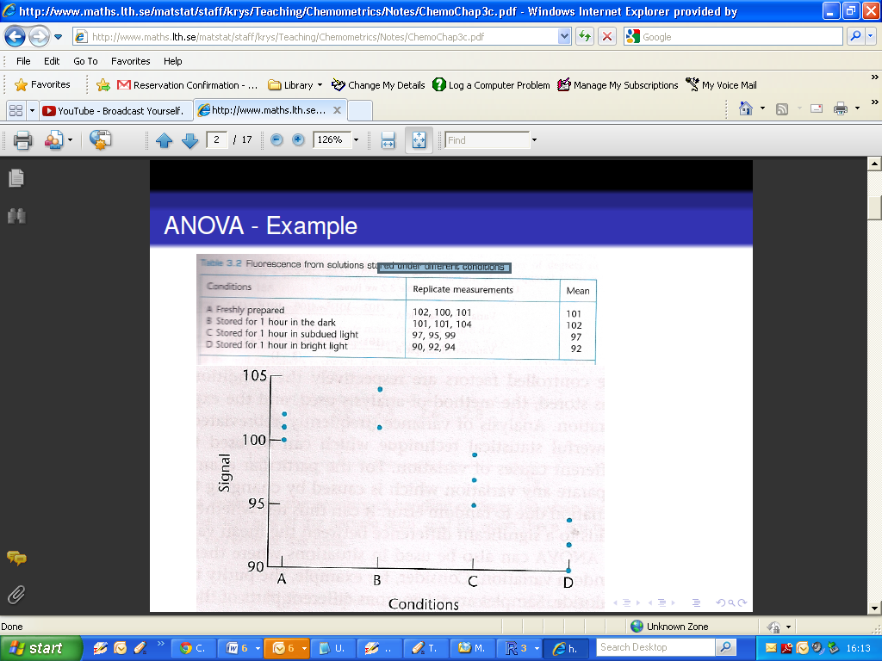

We will carry out a test of

H0 : μA = μB = μC = μD

H1 : Not all the population group means are equal

**Within-Sample Variation**

|  |  |
| --- | --- |
| > A=c(102,100,101)  > var(A)  [1] 1  >  > B=c(101,101,104)  > var(B)  [1] 3 | > C=c(97,95,99)  > var(C)  [1] 4  >  > D=c(90,92,94)  > var(D)  [1] 4 |

The within-variance estimator is the mean of the variances for each category.

**Between-Sample Variation**

The associated degrees of freedom:

* for within-sample ***h(n - 1)*** (in our example 4 x 2 = 8),
* for between-sample ***h - 1*** (in our example 3).
* Total number of degrees freedom ***hn - 1***
* Remark ***hn - 1 = h(n - 1) + h - 1***

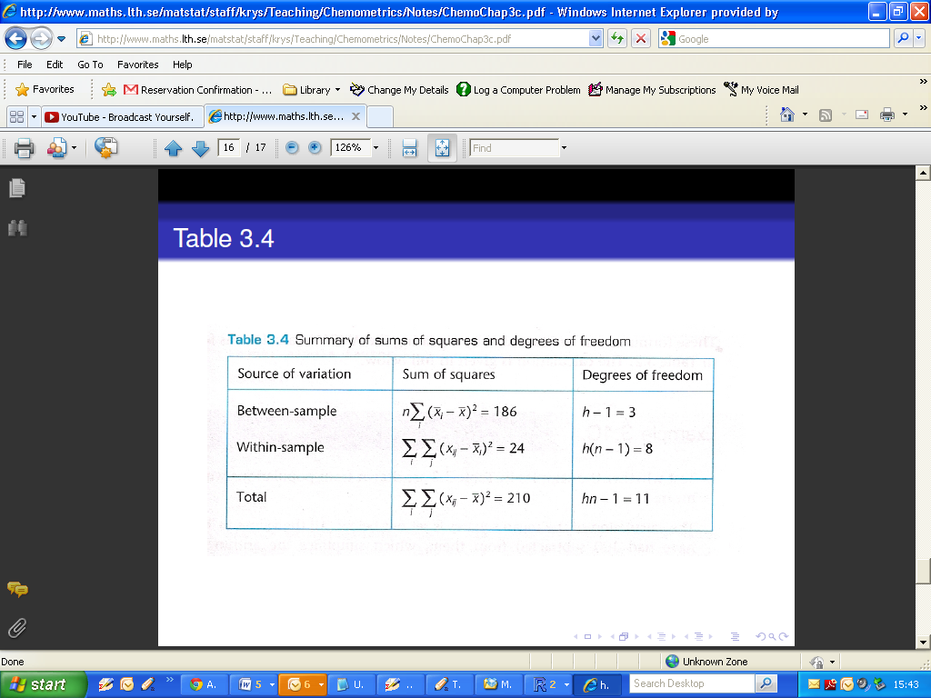

|  |
| --- |
| x=c(102,100,101,101,101,104,97,95,99,90,92,94)  factors=c(rep("A",3),rep("B",3),rep("C",3),rep("D",3))  res=aov(x˜factors)  anova(res) |

The output for this procedure is as follows:

|  |
| --- |
| > anova(res)  Analysis of Variance Table  Response: x  Df Sum Sq Mean Sq F value Pr(>F)  factors 3 186 62 20.667 0.0004002 ***  Residuals 8 24 3  ---  Signif. codes: 0 ‘***’ 0.001 ‘**’ 0.01 ‘*’ 0.05 ‘.’ 0.1 ‘ ’ 1 |

Exercise: Complete the following ANOVA table

|  |
| --- |
| > anova(res)  Analysis of Variance Table  Response: x  Df Sum Sq Mean Sq F value Pr(>F)  factors … 136.1 45.367 ………………… 0.01742 *  Residuals 11 ……… 8.682  ---  Signif. codes: 0 ‘***’ 0.001 ‘**’ 0.01 ‘*’ 0.05 ‘.’ 0.1 ‘ ’ 1 |